These are non required fields.

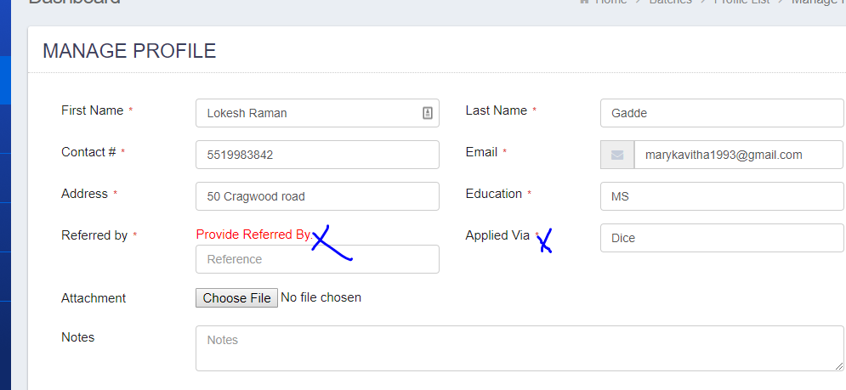

Change the label to “Evaluation On”:

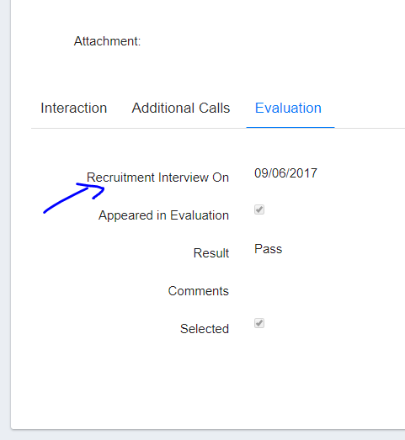

Search should include first name and last name both:

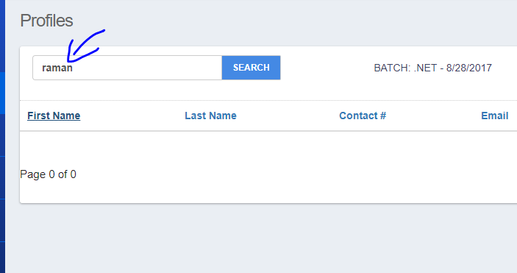

Remove “Time” from all the date fields such as:

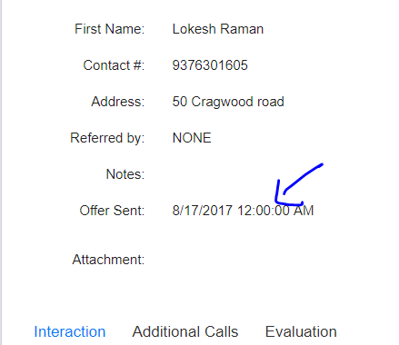

These textboxes needs to convert to dropdowns with all the active users (non-trainee roles)

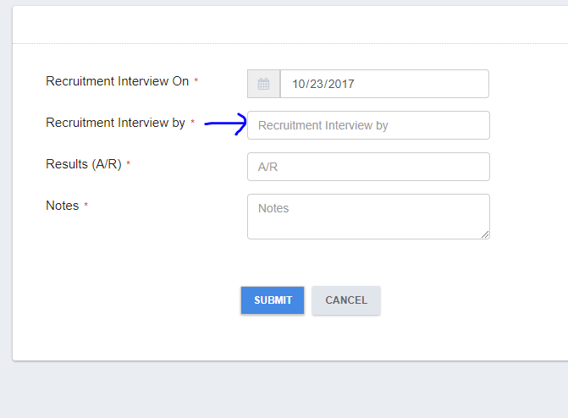

Add a date column “Evaluation on”:

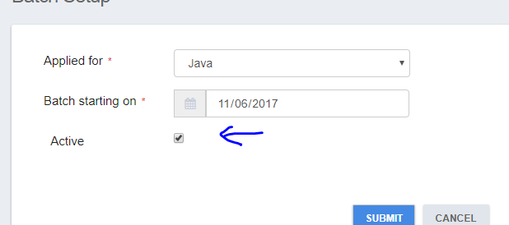

Marketing:

Let’s add a new tab here with the name “Marketing”:

* This tab will only appear to users allowed user roles (we will make it dynamic and controlled from the database table). So basically there will be 4 roles in the system:
  + Recruiters
  + Trainers
  + Sales
  + Trainee
  + Admin(No Master data access)
  + Super Admin(Super Admin should see all Master data)
* When clicked, it will show a list of details below, please note that there may be two or more people who are doing the marketing and if that happens, we will see two or more lines here:
  + Marketing Start Date
  + Sales team name (Please bring the users with Sales roles).
  + Final Resume Link(Word file)
  + Placed(Y/N) it’s a dropdown with Y/N values.
  + Client Name
  + Client Location
  + Project Start Date
  + Hourly Rate($ / Per hour)
  + View details link
* When “View Details” link is clicked, it will show the details and also allows user to make adjustments. PLEASE NOTE THAT CLIENT NAME, CLIENT LOCATION, PROJECT START DATE, HOURLY RATES AND FINAL RESUME are non-mandatory.

Placement Menu: rename this to Marketing.

* When clicked, it will show a list of all the candidates who are in the market with the details below:
  + Candidate name(first name , Last name)
  + Marketing start date (if there are two Marketers are doing it, this date should be the earliest of both).
  + Marketer name(Same concept as above if more than one person is doing it)
  + Technology
  + Total client Interviews (This is the total of total interviews), this number will come from the Trainee portal, so basically candidate will enter this information when he/she attends an interview.
  + View details (When clicked, it will go the candidate profile and will open the “Marketing” tab).

Trainee Portal: Here are the primary goals:

* Allow a trainee to view his/her personal information such as first name, last name, email and contact# and allow edits in it.
* Allow a trainee to login and put his/her daily attendance.
* Allow a trainee to fill the client interview information.
* Allow them to download necessary documents such as Syllabus and study materials.

Screen design: When clicked on “trainee Portal” link:

* Admin user will see a batch to select in a dropdown and weekly attendance for each candidate in a gridview.
* Candidate will login and see their profile at the top with three tabs at the bottom:
  + Daily attendance:
    - Date(system selection, no changes)
    - Absent(checkbox) if checked, need to select a reason from below:
      * Reason dropdown with these values:
        + Sick Leave
        + Client Interview
        + Personal Issue
    - Save button.
  + Clients interview
    - Interview date
    - Client name
    - Notes
  + Downloadable:
    - Syllabus
    - Feedback form(a PDF file)
    - Study materials